

**The University of Azad Jammu and Kashmir, Muzaffarabad**

**Lab Work**

**Name Saqlain Mushtaq**

**Roll No 2024-SE-35**

**Subject CA&LD (lab)**

**Instructor Engr, Sidra Rafeeq**

**Department: Software Engineering**

**AND GATE**

**Procedure to Connect 7408 (AND Gate IC) in EWB**

**1. Open EWB Software**

* Start Electronic Workbench on your computer.

**2. Place the 7408 IC**

* Click on Place → Component.
* 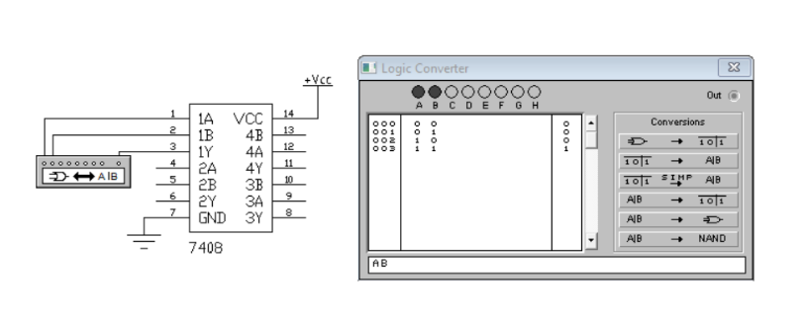Go to the TTL or Digital library.
* Search and select 7408 (it’s the Quad 2-input AND gate).
* Place the 7408 IC onto the workspace.

**3. Connect the Power Supply**

* Pin 14: Connect it to +5V (power supply).
* Pin 7: Connect it to Ground (GND).

This powers up the IC so it works properly.

**4. Set up Inputs**

* 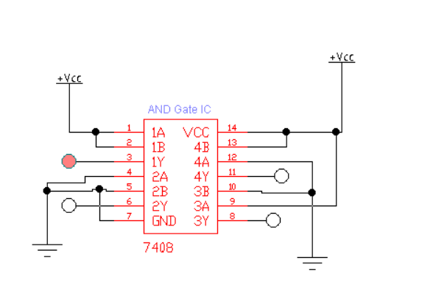From Inputs menu, pick Logic Switches.
* Place two switches (one for each input).
* Connect:
  + One switch to Pin 1 (Input A1).
  + One switch to Pin 2 (Input B1).

**5. Set up Output**

* From Indicators menu, place an LED.
* Put a 330Ω resistor in series with the LED (protects the LED).
* Connect:
  + Pin 3 (Output Y1) → Resistor → LED → Ground.

**6. Start Simulation**

* Click Run (or Start Simulation button).

**7. Test the Circuit**

* Use the switches to turn inputs ON or OFF.
* Observe the LED:
  + LED ON = Output is HIGH (1).
  + LED OFF = Output is LOW (0).
* Try all combinations (00, 01, 10, 11) and record the results.

**OR GATE**

**Procedure to Connect 7432 (OR Gate IC) in EWB**

**1. Open EWB Software**

* 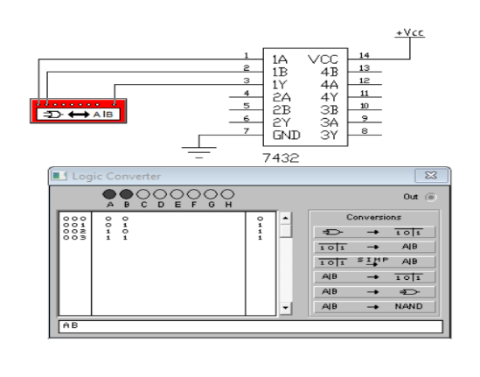Start Electronic Workbench on your computer.

**2. Place the 7432 IC**

* Click Place → Component.
* Find the TTL or Digital family.
* Search for 7432 (Quad 2-input OR gates).
* Place the 7432 IC on your workspace.

**3. Connect Power to the IC**

* 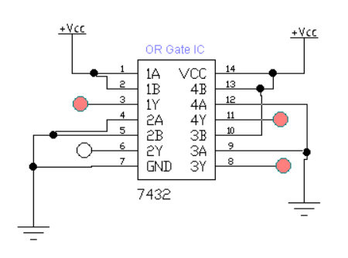Pin 14: Connect to +5V (positive supply).
* Pin 7: Connect to Ground (GND).

⚡ This step powers the IC so it can work correctly during simulation.

**4. Set Up Inputs**

* From the Inputs menu, place two logic switches.
* Connect:
  + First switch to Pin 1 (Input A1).
  + Second switch to Pin 2 (Input B1).

**5. Set Up Output]**

* From the Indicators menu, place an LED.
* Add a 330Ω resistor between the output and the LED.
* Connect:
  + Pin 3 (Output Y1) → Resistor → LED → Ground.

**6. Start the Simulation**

* Click Run to start the simulation.

**7. Test and Observe**

* Toggle the switches through different combinations (00, 01, 10, 11).
* Watch the LED:
  + LED ON = Output is HIGH (1).
  + LED OFF = Output is LOW (0).

Record the output to make your truth table

**NAND GATE**

**Procedure to Connect 7400 (NAND Gate IC) in EWB**

**1. Open EWB Software**

* 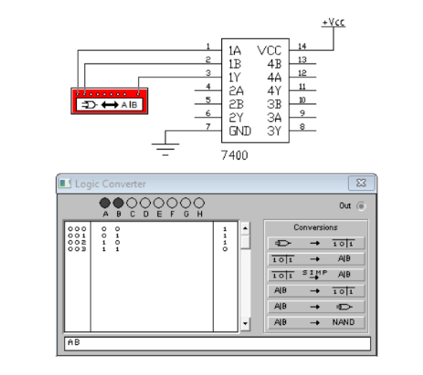Start Electronic Workbench on your computer.

**2. Place the 7400 IC**

* Go to Place → Component.
* Find the TTL or Digital library.
* Search for 7400 (Quad 2-input NAND gate).
* Drag and place the IC on your workspace.

**3. Connect Power to the IC**

* Pin 14: Connect it to +5V (positive supply).
* Pin 7: Connect it to Ground (GND).

⚡ This powers up the IC so it works properly in the simulation.

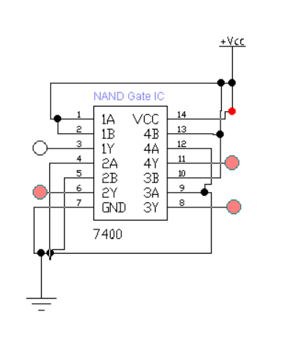**4. Setup Input Connections**

* From the Inputs menu, place two logic switches.
* Connect:
  + First switch to Pin 1 (Input A1).
  + Second switch to Pin 2 (Input B1).

**5. Setup Output Connection**

* From the Indicators menu, place an LED.
* Add a 330Ω resistor in series with the LED.
* Connect:
  + Pin 3 (Output Y1) → Resistor → LED → Ground.

**6. Start the Simulation**

* Press the Run button to start the simulation.

**7. Test and Observe**

* Turn ON and OFF the switches in different combinations (00, 01, 10, 11).
* Watch the LED:
  + LED ON = Output is HIGH (1).
  + LED OFF = Output is LOW (0).

Record the results for each combination to create the truth table.

**NOR GATE**

**Procedure to Connect 7402 (NOR Gate IC) in EWB**

**1. Open EWB Software**

* 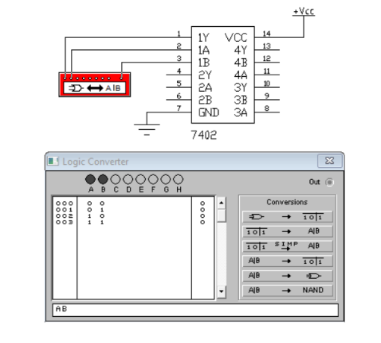Start Electronic Workbench on your computer.

**2. Place the 7402 IC**

* Click Place → Component.
* Go to TTL or Digital library.
* Search for 7402 (Quad 2-input NOR gates).
* Place the 7402 IC onto your workspace.

**3. Connect Power to the IC**

* Pin 14: Connect to +5V (positive power supply).
* Pin 7: Connect to Ground (GND).

⚡ Powering the IC is necessary to make it work properly.

**4. Set Up Inputs**

* From the Inputs section, place two logic switches.
* Connect:
  + First switch to Pin 1 (Input A1).
  + Second switch to Pin 2 (Input B1).

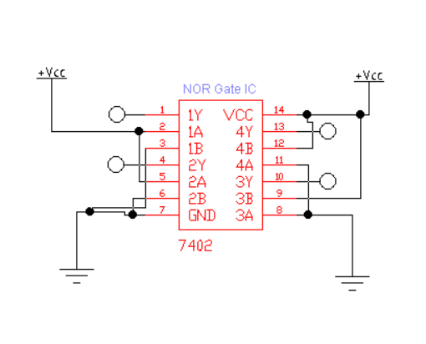**5. Set Up Output**

* From the Indicators section, place an LED.
* Add a 330Ω resistor between the output and LED.
* Connect:
  + Pin 3 (Output Y1) → Resistor → LED → Ground.

**6. Start the Simulation**

* Click Run to start the simulation.

**7. Test and Observe**

* Change the switches to different combinations (00, 01, 10, 11).
* Watch the LED:
  + LED ON = Output is HIGH (1).
  + LED OFF = Output is LOW (0).

Write down the results to create the truth table.

**NOT GATE**

**Procedure to Connect 7404 (NOT Gate/Inverter IC) in EWB**

1. Open EWB Software

* 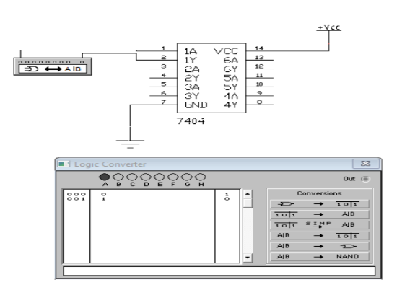Start Electronic Workbench on your computer

**2. Place the 7404 IC**

* Click on Place → Component.
* Find the TTL or Digital library.
* Search for 7404 (Hex Inverter/NOT gates).
* Place the 7404 IC onto your workspace.

**3. Connect Power to the IC**

* Pin 14: Connect to +5V (positive power).
* Pin 7: Connect to Ground (GND).

⚡ This step powers the IC so it works properly.

**4. Set Up Input**

* From the Inputs menu, place one logic switch.
* Connect the switch to Pin 1 (Input A1).

**5. Set Up Output**

* From the Indicators menu, place an LED.
* Add a 330Ω resistor between the output and LED.
* 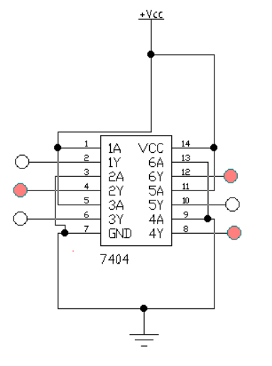Connect:
  + Pin 2 (Output Y1) → Resistor → LED → Ground.

**6. Start the Simulation**

* Click Run to start simulation.

**7. Test and Observe**

* Turn the switch ON and OFF (0 or 1).
* Observe the LED:
  + If input is 0 → LED turns ON (Output 1).
  + If input is 1 → LED turns OFF (Output 0).
* Record the behaviour to create the truth table.

**XOR GATE**

**Procedure to Connect 7486 (XOR Gate IC) in EWB**

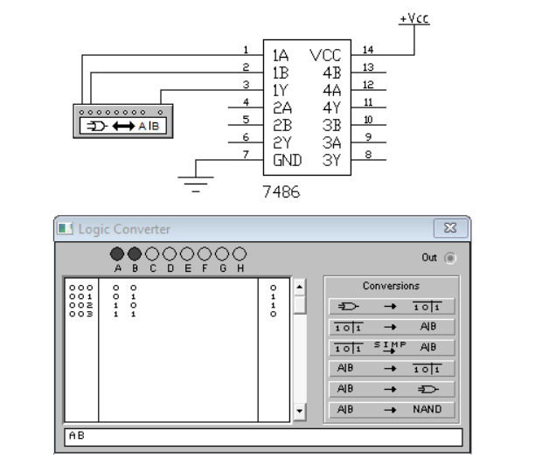**1. Open EWB Software**

* Launch Electronic Workbench on your computer.

**2. Place the 7486 IC**

* Go to Place → Component.
* Find the TTL or Digital section.
* Search for 7486 (Quad 2-input XOR gates).
* Drag and place the 7486 IC onto your workspace.

**3. Connect Power to the IC**

* Pin 14: Connect to +5V (positive supply).
* Pin 7: Connect to Ground (GND).

⚡ This is needed to power the IC so it works during simulation.

**4. Set Up Inputs**

* From the Inputs menu, place two logic switches.
* Connect:
  + One switch to Pin 1 (Input A1).
  + One switch to Pin 2 (Input B1).

**5. Set Up Output**

* From the Indicators menu, place an LED.
* Add a 330Ω resistor in series with the LED.
* 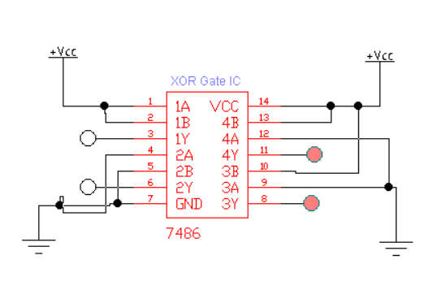Connect:
  + Pin 3 (Output Y1) → Resistor → LED → Ground.

**6. Start the Simulation**

* Click the Run button to begin simulation.

**7. Test and Observe**

* Use the switches to test all input combinations (00, 01, 10, 11).
* Observe the LED:
  + LED ON = Output is HIGH (1).
  + LED OFF = Output is LOW (0).
* Record results to build the truth table.